Support for the Development of Business Units at the Artisan Village, Ta’ Qali
Application Form

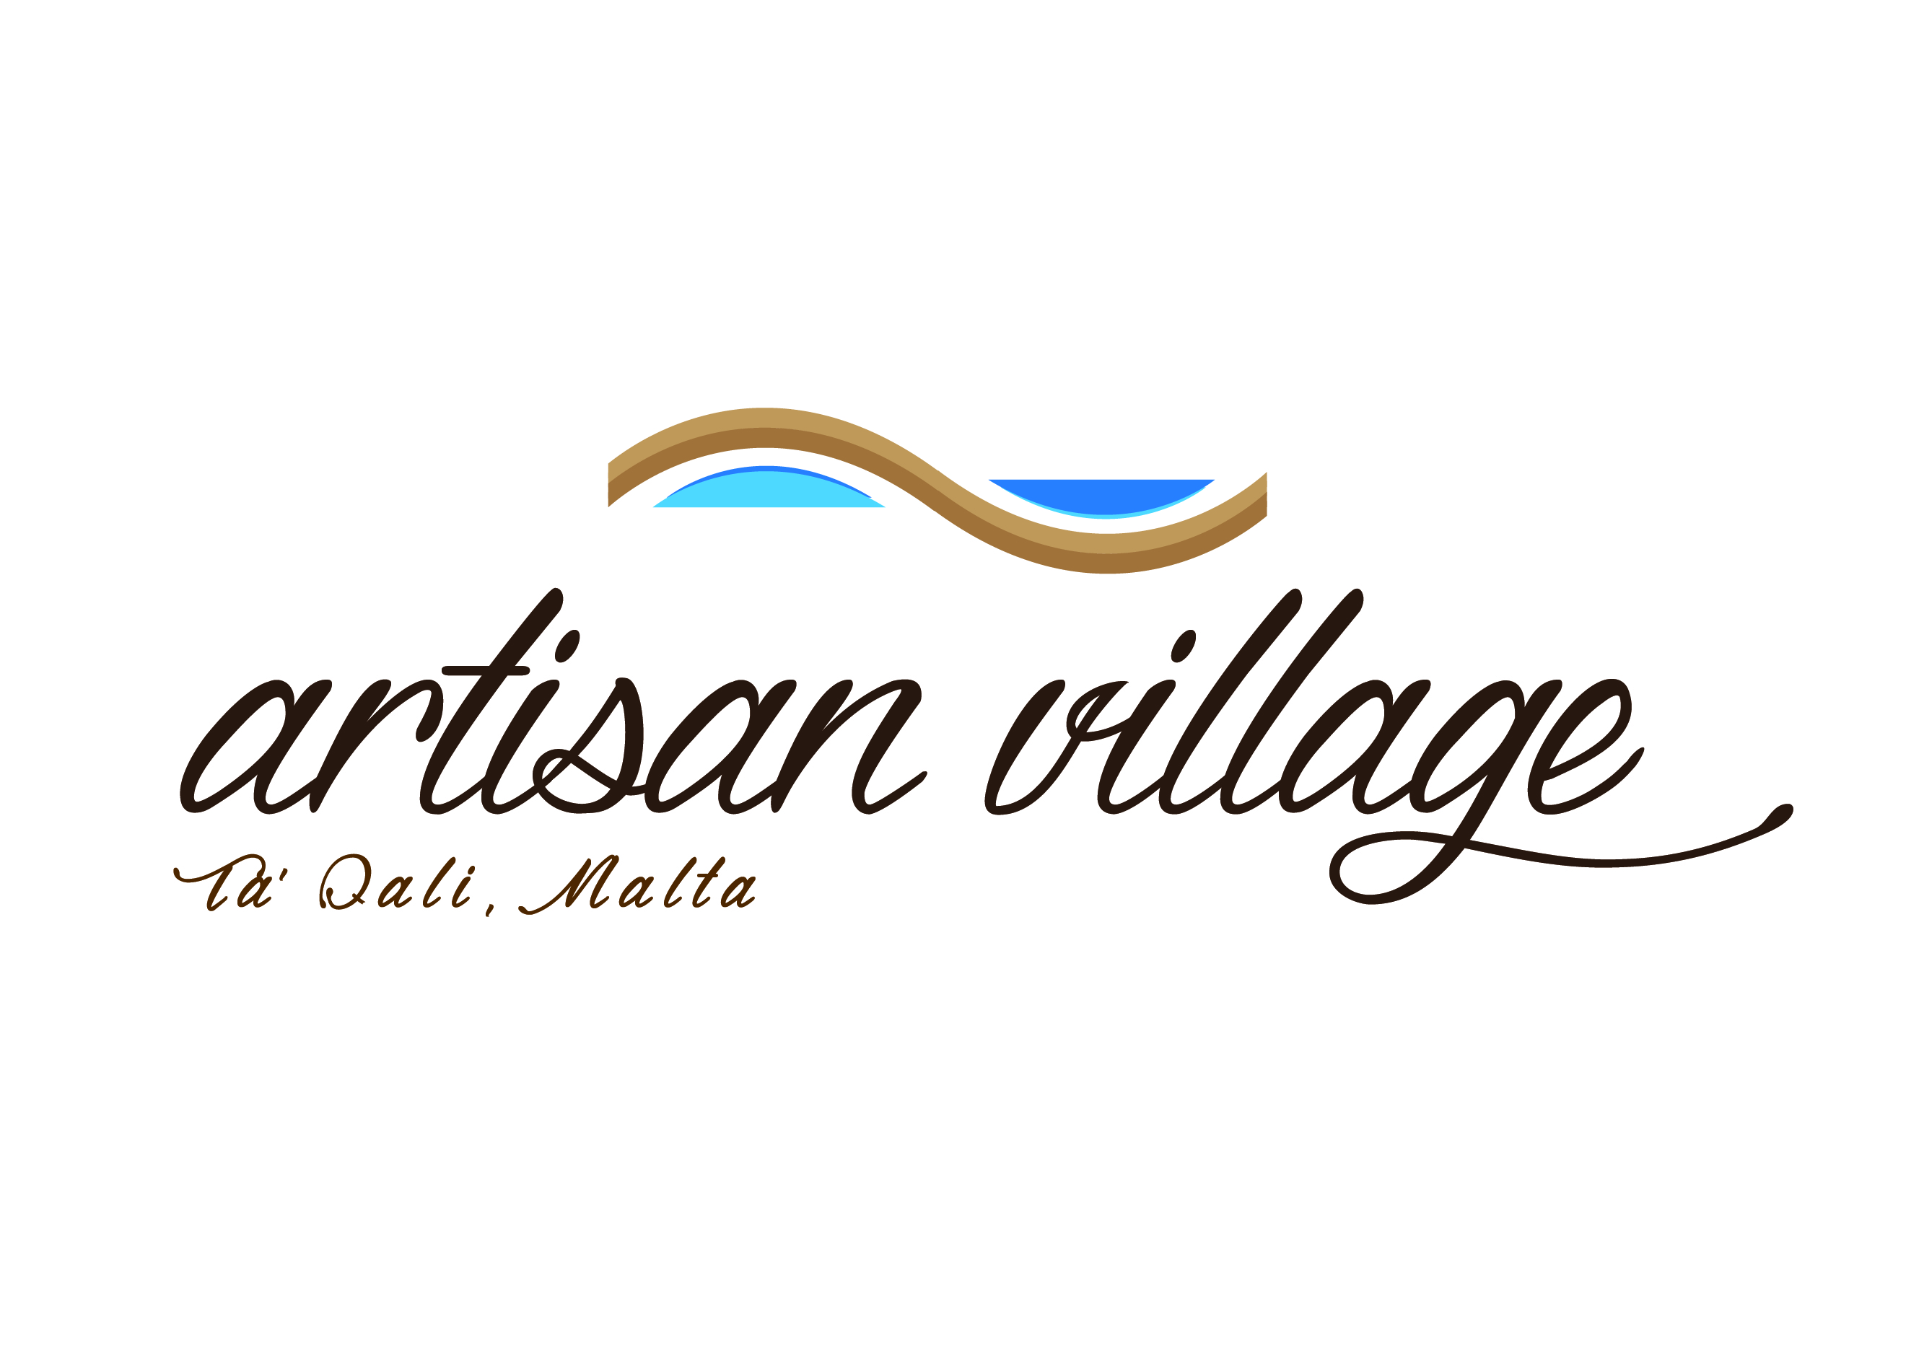

For Office Use Only:

Reference Number
Date Received by Corporation
 |  |  | D | M | Y
Complete Application

Notes to Applicants

This form is to be used by eligible undertakings that wish to benefit from Support for the Development of Business Units at the Artisan Village, Ta’ Qali.

The Application Form and any attached documents will be treated in confidence.

All replies must be clearly explained and substantiated.

Only electronically filled in applications forms will be accepted. Should the application be hand-written or should the form of the application form be altered, the application form will not be evaluated.

Tenants operating from Ta’ Qali may either opt to apply for the Support for the Development of business units at the Artisan Village, Ta’ Qali scheme or the Aid for the Development of Workshops and Associate Retail Outlets at the Ta’ Qali and Ta’ Dbiegi Crafts Village - Loan Interest Subsidy Scheme.

Further information, as well as information and guidance on the filling in of the application form may be obtained by contacting Business First at Malta Enterprise during office hour on 144 or via email on info@businessfirst.com.mt

Applications should reach Malta Enterprise by not later than 31st October 2017.

Malta Enterprise may request further information to support its decision for approval.

1. Applicant Details

1.1 Name of Applicant:
This section should specify the legal name of the undertaking as defined in the Memorandum of Articles. In the case of Partnerships and Co-operatives the name outlined in the deed of partnership should be used in this section. In the case of Sole Traders, the name of the sole trader shall be inserted.

1.2 Address of Applicant:

The address inserted here will be used to address any mail correspondence to the Applicant.

1.3 Applicant’s Telephone Number/s:

The Applicant’s general telephone number/s.

1.4 Applicant’s e-mail:

The Applicant’s general e-mail address.

1.5 Website (URL):

The Applicant’s website address.

1.6 VAT Number:

The Applicant’s VAT Number, as per VAT Certificate, relating to the activities funded under the proposed project.

1.7 Legal Form of Undertaking:

The applicant is requested to list down the legal form (or envisaged legal form) of the undertaking. | Choose an item.

1.8 Registration / Identification Number:

The registration number is the official registration number of the co-operative, company or partnership as defined in the Companies Act – Chapter 387 of the Laws of Malta. In the case of Self Employed, this should be the corresponding Identity Card Number.

1.9 Date Established:

:

This is the date, the undertaking was first established. Where applicable this will be the date of registration as defined in the Companies Act – Chapter 387 of the Laws of Malta. In the case of Self Employed, the date the person registered as self-employed with ETC. In case of Co-operatives. In the case of Co-operatives, the date the co-operative has been registered as per Co-operative Societies Act. | Click here to enter a date.

1.10 Number of Employees at Application Stage:

2. Type of Assistance Requested

2.1 Loan Guarantee

2.2 Grant

3. Amount of Assistance Requested

Construction Costs | €
Total

Finishings | €
Total

Plant and Machinery | €
Total

Equipment | €
Total

Total Assistance Requested (€) including VAT:

- Single Undertaking Details

Does the applicant undertaking have at least one (1) of the following relationships with another undertaking?

- one undertaking has a majority of the shareholders’ or members’ voting rights in another undertaking.

Yes No

- one undertaking has the right to appoint or remove a majority of the members of the administrative, management or supervisory body of another undertaking.

Yes No

- one undertaking has the right to exercise a dominant influence over another undertaking pursuant to a contract entered into with that undertaking or to a provision in its memorandum or articles of association.

Yes No

- one undertaking, which is a shareholder in or member of another undertaking, controls alone, pursuant to an agreement with other shareholders in or members of that undertaking, a majority of shareholders’ or members’ voting rights in that undertaking.

Yes No

- Owns more than 50% shareholding in another undertaking

Yes No

If you replied 'yes' to one or more of the above, complete the table below with details of all undertakings falling under the definitions of single undertaking.

Name of Undertaking | No. of Full Time employees engaged for year 2015 | No. of Full Time employees engaged for year 2016 | Turnover Amount € (2015) | Turnover Amount € (2014) | Balance Sheet Amount € (2015) | Balance Sheet Amount € (2016)

- Check List

The Applicant is requested to provide the Corporation with the below list of documentation to support the application form. Incomplete application will be rejected.

Annex I: Fiscal & Social Security Obligation (below confirmation must be issued not earlier than six (6) months prior to the date of submitting this application)
□ 1. Income Tax compliance Certificate – verification that the applicant is up
to date with Income Tax, Social Security payments or is honouring a
repayment agreement.
□ 2. VAT Compliance Certificate – specifying that the applicant is up to date.
Annex II: De Minimis Declaration Form (pg 11 & 12)

Annex III: Jobsplus Employment History List

Annex IV: a copy of the proposed project development plans as endorsed by Malta Industrial Parks ltd.

Annex V: In case of cash grant to submit a copy of the signed contract for the development of the immovable property (optional)

- Declarations

  - Personal Data Protection

Personal information provided in this form will be processed in accordance with the Data Protection Act, Cap 440 of the Laws of Malta and shall be treated in the strictest confidence.

Information provided in this form will be processed by Malta Enterprise to assess the applicant’s eligibility, for the approval or otherwise of assistance under this scheme, for monitoring implementation of aid granted.

The undersigned consents Malta Enterprise to share information provided in this application with Government Entities or the European Commission where this is strictly necessary for the proper administration of this incentive or where legally required.

The undersigned hereby authorises Malta Enterprise Corporation to process the data contained in this form for the purpose stated above and declare that the information on this form and any other supporting documents given with this application is correct to the best of the undersigned’s knowledge.

5.2 Cumulation of Aid

The undersigned declares that aid approved under this incentive is in line with the terms and conditions set out in the Incentive Guidelines and in line with Cumulation Article 5 of the Commission Regulation (EU) No 1407/2013 of 18 June 2013 on the application of Articles 107 and 108 of the Treaty on the Functioning of the European Union to de minimis aid.

5.3 Double Funding

The undersigned confirms that there has not been any approval or has been granted any public funding, financing or fiscal benefit in respect to the cost items included in this request for aid and will not seek funding or fiscal benefits for these cost items through other National and/or European Union measures. Such measures may include:
- Schemes administered by Malta Enterprise, the Planning and Priorities’ Coordination Division (PPCD), the Measure and Support Division, the Tourism and Sustainable Development Unit (TSDU), Jobsplus, the Malta Council for Science & Technology (MCST), the Regulator for Energy and Water Services (REWS) and government funded schemes operated by other entities (such as JAMIE financial instrument).

- Schemes funded through ERDF, ESF, Cohesion Fund, TEN-T Budget, EAFRD, EFF, LIFE+; Horizon 2020 and other European Union programmes/instruments.

5.4 Outstanding Recovery Order

The undersigned confirms that the applicant is not subject to an outstanding recovery order following a previous Commission decision declaring an aid illegal and incompatible with the internal market should be excluded from the scope of this Regulation.

- Signatures

Name of Applicant (full legal name)

Name and Surname of signatory

authorised to represent the Applicant
(CAPITAL LETTERS)

Position in Establishment

Signature & Company stamp

Date
Click here to enter a date.

Annex II: STATE AID DECLARATION (De Minimis)

If the submitted application is approved, the project will benefit from de minimis State Aid in line with Commission Regulation (EU) No 1407/2013 of 18 December 2013 on the application of Articles 107 and 108 of the Treaty on the Functioning of the European Union to de minimis aid.
Commission Regulation (EU) No 1407/2013 allows a ‘single undertaking’ to receive an aggregate maximum amount of de minimis aid of €200,000 under all de minimis aid measures, over a period of three ‘fiscal years’. This aggregate maximum threshold applies in principle to all economic sectors with the exception of a ‘single undertaking’ performing road freight transport for hire and reward for which a lower de minimis threshold of €100,000 over any period of three ‘fiscal years’ applies. The agriculture and fisheries sectors are subject to different thresholds and criteria. For the purpose of this declaration, the term ‘single undertaking’ shall have the meaning as established in Commission Regulation (EU) No 1407/2013. Moreover, ‘fiscal year’ means the fiscal year as used for tax purposes by the undertaking concerned.
This maximum threshold would include all State aid granted under this scheme and any other State aid measure granted under the de minimis rule. Any de minimis aid received in excess of the established threshold will have to be recovered, with interest, from the undertaking receiving the aid.
The following is an indicative list of the possible forms of State Aid:
- Grants from public bodies
- Loans or loan guarantees at favourable rates
- Tax benefits
- Waiving or deferral of fees or interest normally due
- Marketing and advertising assistance
- Consultancy, training and other support provided either free or at a reduced rate
- Aid for investment in environmental projects or research and development assistance
- Purchase, rent or lease of immovable property at less than market rate.
Potentially any assistance from a public body may constitute State aid. Should you have any doubts whether any public assistance received is de minimis aid, you should contact the agency or department from which the assistance was received in order to ascertain this.

DECLARATION

I declare that a comprehensive amount of de minimis aid received to date during the current fiscal year and the previous two fiscal years is:
Fiscal Year 2015 | Fiscal Year 2016 | Fiscal Year 2017 | TOTAL
€ | € | € | €

A breakdown of the source, type and amount of all de minimis aid received as well as that applied from any State aid grantor, is presented overleaf.
Business Undertaking (Full Legal Name) |  | VAT Registration Number
Name and Surname (BLOCK CAPITALS) |  | Position in Establishment
 |  | 11/01/2017
Signature |  | Date

Detailed information concerning applicable State aid under the de minimis rule for fiscal year 2015, 2016, 2017

SECTION 1 – DE MINIMIS STATE AID AWARDED

Date | Source/Grantor | Type of State Aid  (Name of Measure) | Awarded to | Amount in €
TOTAL: |  |  |  |  | A1

SECTION 2 – DE MINIMIS STATE AID STILL PENDING FOR APPROVAL

Date | Source/Grantor | Type of State Aid  (Name of Measure) | Awarded to | Amount in €
TOTAL: |  |  |  |  | A2

SECTION 3 – DE MINIMIS STATE AID REQUESTED IN THIS APPLICATION

Date | Source/Grantor | Type of State Aid  (Name of Measure) | Amount in €
Click here to enter a date. | Malta Enterprise | Support for the Development of Business Units at the Artisan Village, Ta’ Qali |  | A3

TOTAL of Sections 1,2 and 3 above (A1 + A2 + A3): | €

If a VAT Number is not yet available it will need to be presented before any aid is granted

