Gozo Transport Grant Scheme

Determination for Eligibility

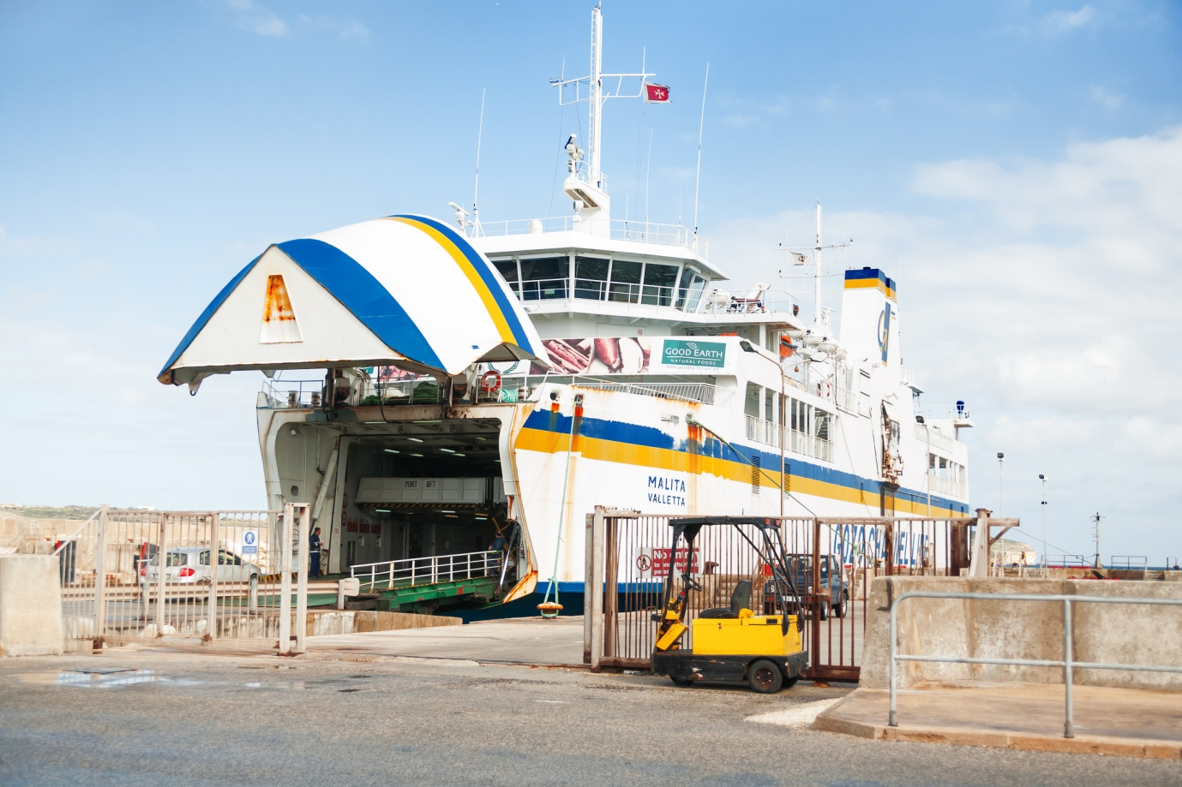

Notes to Applicants

- This form is to be used by eligible undertakings that wish to benefit from the Gozo Transport Grant Scheme.

- This Application Form and any attached documents will be treated as confidential throughout and after the evaluation process.

- All entries in this application must be clearly explained and substantiated.

- Only electronically filled in application forms will be accepted. Should the application be handwritten, or should the format of the application form be altered, the application form will be rejected.

- Further information, as well as information and guidance on the filling in of this application form may be obtained by contacting Malta Enterprise (Gozo Office) during office hours by calling 2156 4700 or via email on info@businessfirst.com.mt

- Malta Enterprise may request further information.

1. Applicant Details

1.1 Name of Applicant:
This section should specify the legal name of the enterprise as defined in the Memorandum of Articles. In the case of Partnerships and Co-operatives the name outlined in the deed of partnership should be used in this section. In the case of Sole Traders, the name of the sole trader shall be inserted.

1.2 Address of Applicant:

This section should specify the address of the Applicant. The address inserted here will be used to address any mail correspondence to the Applicant.

1.3 Applicant’s Telephone Number/s:

The Applicant’s general telephone number/s.

1.4 Applicant’s e-mail:

The Applicant’s general e-mail address.

1.5 Website (URL):

The Applicant’s website address.

1.6 VAT Number:

The Applicant’s VAT Number, as per VAT Certificate, relating to the activities funded under the proposed project.

1.7 Legal Form of Undertaking:

The applicant is requested to list down the legal form (or envisaged legal form) of the undertaking. | Choose an item.

1.8 Registration / Identification Number:

The registration number is the official registration number of the co-operative, company or partnership as defined in the Companies Act – Chapter 387 of the Laws of Malta. In the case of Self Employed, this should be the corresponding Identity Card Number.

1.9 NACE Code:

:

Eurostat Nace Rev. 2 Statistical classification of economic activities in the European Community. Note: Unless NACE falls within category ‘C’, the applicant may not be assisted through this Scheme.

1.11 Applicant Contact Details
1.11.1 Contact Person

1.11.2 Designation

1.11.3 e-mail

1.11.4 Phone Number

2. Business Details

2.1 Provide a brief description of the company’s manufacturing activities in Gozo and the type of goods / material being transported.

3. Declarations

3.1 Personal Data Protection
I/We as Director/s of applying for a determination of eligibility in line with the official incentive Guidelines issue date 1st January 2016 for the Gozo Transport Grants 2016 - 2020 as provided for in the Investment Aid (July2014) Regulations as subsidiary legislation 463.04 to the Malta Enterprise Act, Chapter 463 of the Laws of Malta, declare that:
i) Application Completion
I/We have fully understood the terms and conditions set out in the official Incentive Guidelines issue Date April 2016 for the Gozo Transport Grants 2016. We confirm that the information provided in this application is correct.
ii) Transport of Goods
The undertaking is applying for assistance in respect of expenses related to the transportation of machinery, plant, materials, goods and products, required for the undertaking’s manufacturing activities in Gozo.
ii) NACE Verification
I/We am/ are authorising Malta Enterprise Corporation to check the NACE category allocated to the Company with the National Statistics Office (NSO). This will be for the sole purpose of verifying that the assigned NACE code is within the eligible activities in terms of Section 3 ‘Eligibility Undertakings’ of the official Incentive Guidelines Issue Date 1st January 2016 for the Gozo Transport Grants 2016 – 2020.

Personal information provided in this form will be processed in accordance with the Data Protection Act, Cap 440 of the Laws of Malta and shall be treated in the strictest confidence.

Information provided in this form will be processed by Malta Enterprise to assess the applicant’s eligibility, for the approval or otherwise of assistance under this scheme, for monitoring implementation of aid granted.

The undersigned consents Malta Enterprise to share information provided in this application with Government Entities or the European Commission where this is strictly necessary for the proper administration of this incentive or where legally required.

The undersigned hereby authorises Malta Enterprise Corporation to process the data contained in this form for the purpose stated above and declare that the information on this form and any other supporting documents given with this application is correct to the best of the undersigned’s knowledge.

3.2 Cumulation of Aid
The undersigned declares that aid approved under this incentive is in line with the terms and conditions set out in the Incentive Guidelines and in line with Cumulation Article 8 of the Commission Regulation (EU) No 651/2014 of 17 June 2014 declaring certain categories of aid compatible with the internal market in application of Articles 107 and 108 of the Treaty.

3.3 Double Funding
The undersigned confirms that there has not been any approval or has been granted any public funding, financing or fiscal benefit in respect to the cost items included in this request for aid and will not seek funding or fiscal benefits for these cost items through other National and/or European Union measures. Such measures may include:
- Schemes administered by Malta Enterprise, the Planning and Priorities’ Coordination Division (PPCD), the Measure and Support Division, the Tourism and Sustainable Development Unit (TSDU), the Employment & Training Corporation (ETC), the Malta Council for Science & Technology (MCST), the Regulator for Energy and Water Services (REWS) and government funded schemes operated by other entities (such as JAMIE financial instrument).

- Schemes funded through ERDF, ESF, Cohesion Fund, TEN-T Budget, EAFRD, EFF, LIFE+; Horizon 2020 and other European Union programmes/instruments.

3.4 Outstanding Recovery Order
The undersigned confirms that the applicant is not subject to an outstanding recovery order following a previous Commission decision declaring an aid illegal and incompatible with the internal market should be excluded from the scope of this Regulation.

3.5 Transparency Obligations
For any individual aid awarded in excess of EUR 500 000, the details of the beneficiary; the aid awarded; and the project details; shall be published as provided for in Article 9 of the COMMISSION REGULATION (EU) No 651/2014 of 17 June 2014 declaring certain categories of aid compatible with the internal market in application of Articles 107 and 108 of the Treaty.
By submitting this application, I hereby acknowledge that the Corporation shall abide with any applicable transparency rules and may publish and make available to third parties information as required by such rules.

4. Signature

Name of Applicant (full legal name)

Name and Surname of signatory authorised to represent the Applicant (CAPITAL LETTERS)

Position in Establishment

Signature & Company Stamp
Date | Click here to enter a date.

If a VAT Number is not yet available it will need to be presented before any aid is granted

